HEALTHY LIFESTYLE REWARDS

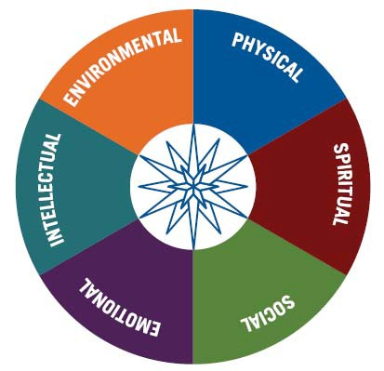
What is the Healthy Lifestyle Rewards Program?
Moravian College is introducing a wellness incentives/rewards program. We believe that making healthy lifestyle choices can impact your health and well-being now and in the future and help to reduce the risk of major chronic diseases like cardiovascular disease, cancer, and diabetes. Making these healthy choices can now earn you points towards a reward.

Who can participate in the program?
All benefits eligible employees can participate in the program to start earning rewards. Employees do not have to be enrolled in the Moravian College health plan to participate.

How can I earn rewards?
Employees can earn up to 15 points by participating in the following healthy lifestyle activities during the calendar year. Participants must submit proof of each activity to the Human Resources Department. Approved activity will be tracked on the Healthy Lifestyle Rewards Passport.
Point  Value | Healthy Lifestyle Reward Description | Proof Required
3 | Complete Highmark Wellness Profile (see HR for details) | None
3 | Provide proof of completing a Weight Management Program (8-weekmin) | Certificate of completion
2 | Complete one PAWS Fitness session (session must run at least one day per week for 5 weeks) | Signature of instructor
1 | Receive an age appropriate Wellness Screening as identified by your Health Insurance Carrier’s Preventive Schedule. Ex. Body mass index check, blood pressure check, glucose screening, cholesterol screening,  etc.(Limited to 2 rewards points.) | EOB*
1 | Receive an annual Immunization as identified in your Health Insurance as detailed on Highmark’s Preventive Schedule | EOB or receipt
1 | Attend a PAWS Lunch & Learn (limited to 2 rewards points) | Registration
1 | Complete an annual physical exam, mammogram, or colonoscopy | EOB
1 | Receive a routine dental exam | EOB or receipt
1 | Receive a routine eye exam | EOB or receipt
1 | Participate in a walking/ running program/event | Registration/Name on roster
1 | Attend the Annual Open Enrollment or Benefits Fair educational session (limited to 2 reward points) | Signature of presenter
1 | Participate in a Meditation Circle on campus. | Signature of instructor

What are the rewards for participating in the program?
*EOB = Explanation of Benefits

Rewards points can be redeemed by submitting a Healthy Lifestyle Rewards Passport to the Human Resources Office at the end of the program year. Rewards are as follows:

08/2016
$25 Cash | 3 points | $100 Cash | 9 points
$50 Cash | 6 points | $200 Cash | 15 points

